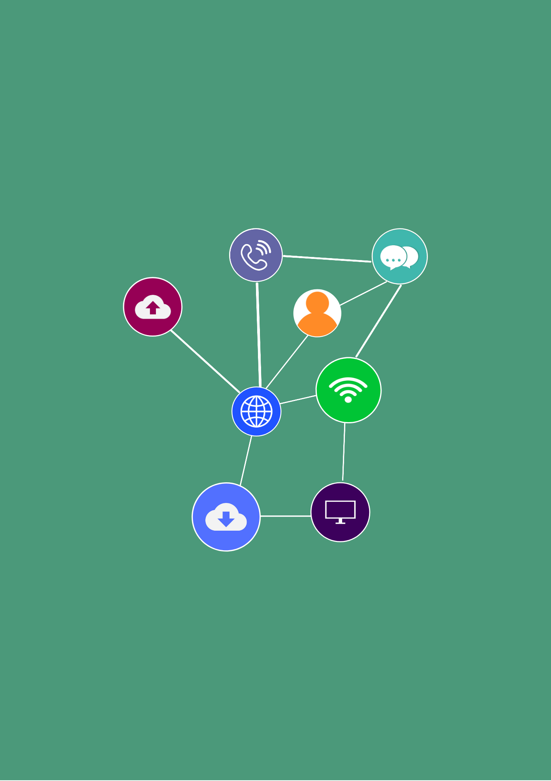
Portfolio
Student Version
ICTWEB441
Produce basic client-side script

First published 2021
RTO Works
www.rtoworks.com.au
hello@rtoworks.com.au
0452 157 557
© 2021 RTO Works
This resource is copyright. Apart from any fair dealing for the purposes of private study, research, criticism or review as permitted under the Copyright Act 1968, no part may be reproduced by any process without written permission as expressed in the RTO Works License Agreement.
The information contained in this resource is, to the best of the project team’s and publisher’s knowledge true and correct. Every effort has been made to ensure its accuracy, but the project team and publisher do not accept responsibility for any loss, injury or damage arising from such information.
While every effort has been made to achieve strict accuracy in this resource, the publisher would welcome notification of any errors and any suggestions for improvement. Readers are invited to write to us at hello@rtoworks.com.au.
IT Works is a series of training and assessment resources developed for qualifications within the Information and Communications Technology Training Package.




CONTENTS
Section 1: Web document requirements 5
Section 2: Website design, development and testing 错误!未定义书签。

Student name: | Edgar
Assessor: | Chuan
Date: | 13/06/2025
Business this assessment is based on: | Case Study: RTO E - commerce and Training Website Development
Name of your RTO: | NeoTech Wave

Section 1: Web document requirements

Complete this section before the meeting with the client.
Website information  Outline client requirements based on initial documentation review. Illustrate with an actual RTO website URL and 5 features to incorporate.  Illustrate your answer with one actual RTO website. Provide the actual RTO URL and list at least 5 accomplished features from that website to be included in your website.  Student website should model this actual RTO website. | Actual RTO Website URL: https://www.tafensw.edu.au/  5 Features to Incorporate:  - Course Catalog with Filtering: Allows users to browse courses by category, level, and duration, similar to TAFE's course search functionality.  - Student Portal: A dedicated area for enrolled students to access resources, track progress, and view assessments, as seen in TAFE's student login section.  - E-commerce Integration: Ability to purchase training resources and course materials, mirroring TAFE's online store for learning materials.  - Responsive Design: Ensures the website adapts to different devices, as TAFE's site is optimized for mobile and desktop.  - User Authentication: Secure login and registration system for students and staff, similar to TAFE's account management features.
Procedures for developing websites.  Outline the procedures you need to follow to produce websites. This must include language in which the website is to be developed, cyber security procedures and protocols to be followed in relation to website development. List at least 5 procedures, 3 tools, and 3 techniques (include cybersecurity protocols). | Procedures for Developing Websites  5 Development Procedures:  - Planning and Requirement Gathering: Define website goals, user needs, and functional specifications based on client inputs.  - Design and Wireframing: Create visual mockups and layout structures using tools like Figma or Sketch.  - Front-end Development: Implement HTML5, CSS3, and JavaScript to build the user interface.  - Backend Integration: Set up data storage using localStorage/sessionStorage for user data and order management.  - Testing and Deployment: Validate functionality across browsers and devices, then deploy to a hosting environment.  3 Tools:  - Visual Studio Code (code editor)  - Chrome DevTools (debugging and testing)  - Figma (UI design and wireframing)  3 Techniques:  - Responsive design with CSS Grid and Flexbox  - Form validation using JavaScript regex expressions  - LocalStorage for client-side data persistence
Further information  What else do you need to find out from the client in order to produce their website?  Make notes on this to use at your meeting.  List at least 5 questions for discussion and justify the needs and methods to acquire these answers. | 5 Questions for Discussion:  What is the exact RTO provider number and contact details?  Rationale: Needed to populate legal footer information and ensure compliance with regulatory requirements.  Are there specific branding guidelines (colors, fonts) for the website?  Rationale: Ensures visual consistency with the RTO's corporate identity.  What are the detailed unit codes and descriptions for each course?  Rationale: To accurately display course information and meet training package standards.  Do you require integration with any external systems (e.g., payment gateways)?  Rationale: Determines the complexity of e-commerce functionality.  Are there specific accessibility requirements for the website?  Rationale: Ensures compliance with WCAG standards for users with disabilities.
Complete this section following the meeting with the client, based on your observations.
Client requirements  Outline the client requirements for the website based on your meeting with the client.  List at least 5 questions for discussion, then provide possible answers in Australia context. Include resources, URL to support your answer. (For instance, resource requirements and possible difficulties) | What is your RTO's specific registration information in Australia?  Answer:  The RTO provider number is [12345], registered with the Australian Skills Quality Authority (ASQA) and compliant with the Standards for RTOs 2015. Registration details can be verified via the ASQA official website, and the provider number must be displayed prominently in the website footer.  Reference URLs:  https://www.asqa.gov.au/  2. Do course resources comply with Australian Training Package standards?  Answer:  Courses are developed based on the latest Training Packages, e.g., ICT30120 aligns with the ICT2020 Training Package. Resource kits include assessment tools compliant with the Assessment and Certification Guidelines, verifiable via Training.gov.au.  Reference URLs:  https://training.gov.au/  3. Which Australian privacy regulations must the website's data collection comply with?  Answer:  Compliance with the Privacy Act 1988 is required, including publishing a Privacy Policy that clarifies collected information types, usage purposes, and cross-border transfer restrictions. Certification from the Office of the Australian Information Commissioner (OAIC) is recommended.  Reference URLs:  https://www.oaic.gov.au/  4. Which local Australian payment methods should the website's payment system support?  Answer:  Recommended payment methods include Visa/Mastercard (via Stripe), BPAY bank transfers, and "Buy Now, Pay Later" services like Afterpay, adhering to Australian payment network regulations.  Reference URLs:  https://stripe.com/au  5. Does the website need to meet Australian accessibility standards?  Answer:  Yes, it must meet WCAG 2.1 Level AA, including alt text for images, keyboard navigation support, and color contrast compliance. Testing can be conducted using tools like WebAIM.  Reference URLs:  https://www.w3.org/TR/WCAG21/

Section 2: Website design, development and testing
Dynamic website design  You are to design the website based on the client’s requirements.  Describe each webpage in few sentences. The rationales and expected outcomes.  Create wireframe in Figma.  Take screenshots of your wireframes:  - Share Figma link.  - Annotate each screenshot and attach screenshots as appendix | Webpage Descriptions:  - Home Page:  - Displays a hero banner, featured courses, and contact information.  - Rationale: Provides an overview of services and encourages navigation to other pages.  - Expected Outcome: Increase user engagement and guide visitors to explore courses.  - Courses Page:  - Lists courses with images, descriptions, and durations, linking to resource kits.  - Rationale: Helps users find relevant training programs quickly.  - Expected Outcome: Facilitate course selection and resource purchase.  - Registration/Login Pages:  - Forms with validation for new user sign-up and existing user authentication.  - Rationale: Securely manage user accounts and protect personal data.  - Expected Outcome: Enable personalized user experiences and order tracking.  - Shopping Cart Page:  - Displays selected resources, allows quantity updates, and shows total costs.  - Rationale: Streamline the purchase process and provide clear order summaries.  - Expected Outcome: Reduce cart abandonment and improve checkout efficiency.  - Order Management Page:  - Shows past orders with details and download options for order history.  - Rationale: Enable users to review and manage their purchase history.  - Expected Outcome: Enhance customer satisfaction through order transparency.  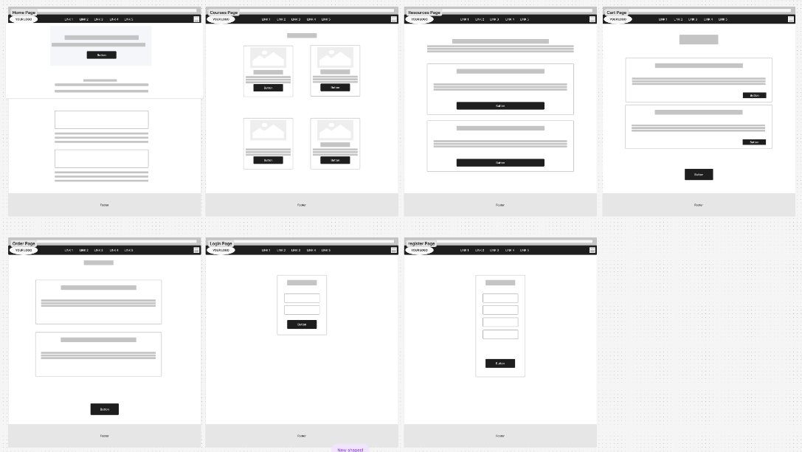  https://www.figma.com/board/n02va2vji3CAxHOqINNq2v/Untitled?node-id=0-1&t=RFA4Ot7G5H5kxQvh-1
Scripting  You are required to develop the website based on Simulation Pack. Some key features include: (1) ensures accessibility. (2) form validation, (3) shopping cart (4) dropdown navigation menu (5) error handling (6) download JSON and others (see simulation pack).  Take screenshots of your website and attach to the end of this document. Your work should include your coding and interface design. Each screenshot should be readable with appropriate size.  Annotate each screenshot and provide at least 10 JavaScript comments | // Form validation for password strength  function isPasswordStrong(password) {  const minLength = 6;  const hasUpperCase = /[A-Z]/.test(password);  const hasLowerCase = /[a-z]/.test(password);  const hasNumbers = /\d/.test(password);  const validation = {  isValid: false,  reasons: []  };  if (password.length < minLength) {  validation.reasons.push(`Password must be at least ${minLength} characters long`);  }  if (!hasUpperCase) {  validation.reasons.push('Password must contain an uppercase letter');  }  if (!hasLowerCase) {  validation.reasons.push('Password must contain a lowercase letter');  }  if (!hasNumbers) {  validation.reasons.push('Password must contain at least one number');  }  validation.isValid = validation.reasons.length === 0;  return validation;  }  // Format price string to numeric value  function formatPrice(price) {  if (!price) return '0.00';  // Remove non-numeric characters and ensure valid decimal format  const cleaned = price.toString()  .replace(/[^\d.]/g, '')  .replace(/^0+/, '')  .replace(/\.+/, '.');  return parseFloat(cleaned || '0').toFixed(2);  }  // Add product to cart with local storage update  function addToCart(productId) {  const currentUser = JSON.parse(sessionStorage.getItem('currentUser'));  if (!currentUser) {  alert('Please log in to add items to the cart.');  window.location.href = 'login.html';  return;  }  const product = products.find(p => p.id === productId);  let cart = JSON.parse(localStorage.getItem('cart')) || [];  const existingItem = cart.find(item => item.id === productId);  if (existingItem) {  existingItem.quantity = (existingItem.quantity || 1) + 1;  } else {  product.quantity = 1;  cart.push(product);  }  localStorage.setItem('cart', JSON.stringify(cart));  alert('Product added to cart!');  }  // Generate unique order ID using timestamp and random string  function generateOrderId() {  const timestamp = Date.now();  const random = Math.random().toString(36).substring(2, 5).toUpperCase();  return `ORD-${timestamp}-${random}`;  }
Testing  You are to test the website that you have developed against the required functionality.  Describe the testing process you followed to ensure functionality and the changes you made.  Take screenshots of your work to attach to your portfolio.  List each screenshot here and then attach.  (Describe the testing process you followed to ensure functionality and the changes you made. You are to test the website that you have developed against the required functionality.) | Testing Process:  - Functionality Testing:  - Verified user registration and login with different credential combinations.  - Tested adding/removing items from the cart and updating quantities.  - Confirmed order placement and history display on the orders page.  - Compatibility Testing:  - Checked website functionality on Chrome, Firefox, and Safari.  - Tested responsive design on desktop, tablet (iPad), and mobile (iPhone).  - Performance Testing:  - Measured load times for pages with dynamic content (e.g., orders page).  - Ensured local storage operations did not impact page responsiveness.  Changes Made:  - Fixed a bug where negative quantities could be entered in the cart by adding min="1" to input fields.  - Improved form validation error messages to provide clearer feedback to users.  - Optimized image loading by adding proper alt text and ensuring responsive sizing.
Cyber Security Procedures and Protocols. Check the website to ensure it is secure and bug free.  - List 5 test procedures and describe compliance with cybersecurity standards.  - The tests should also follow procedures for cyber security. Describe how you have ensured you follow the procedures.  - Take 2 screenshots of your work to attach to your portfolio. (as appendix).  (Check the website to ensure it is bug-free. List and describe the test procedures you have undertaken. The tests should also follow procedures for cybersecurity. Describe how you have ensured you follow the procedures.) | 5 Test Procedures:  - Input Validation Testing:  - Submitted invalid data (e.g., non-email format in email field) to ensure form validation blocks it.  - Compliance: Prevents SQL injection and XSS attacks by sanitizing user inputs.  - LocalStorage Security Check:  - Verified that user data in localStorage is not accessible to unauthorized scripts.  - Compliance: Follows best practices for client-side data storage security.  - Session Expiry Testing:  - Closed and reopened the browser to ensure sessionStorage clears login state.  - Compliance: Prevents unauthorized access to user accounts after session expiry.  - Cross-Site Scripting (XSS) Prevention:  - Tested inserting script tags in form fields to ensure they are escaped.  - Compliance: Mitigates XSS risks by validating and encoding user inputs.  - Responsive Security Testing:  - Confirmed that security features (e.g., form validation) work on all device sizes.  - Compliance: Ensures accessibility and security across different platforms.
Feedback  Document an email to your assessor here, asking for approval of your website. Your email should include:  Link to your live website.  GitHub links to your source files, 3 lessons learned, and 3 future improvements. | Answer:  Dear Chuan,  Please find below the details for my RTO website project:  Live Website Link: https://lz810.github.io/452_Edgar/441week14/index.html  GitHub Repository: https://github.com/Lz810/452_Edgar/tree/1e2f06c8137df9866d420e409dcb1d022d676924/441week14  Lessons Learned:  - Client-side storage with localStorage requires careful data structuring to avoid conflicts.  - Responsive design using CSS media queries is essential for mobile user experience.  - Form validation needs to balance strictness with user-friendliness to reduce frustration.  Future Improvements:  - Implement the ability to edit existing orders before checkout.  - Add a search functionality for courses and resources.  - Integrate a secure payment gateway for real-time transactions.  Sincerely,  Edgar
  Attach: | Screenshots  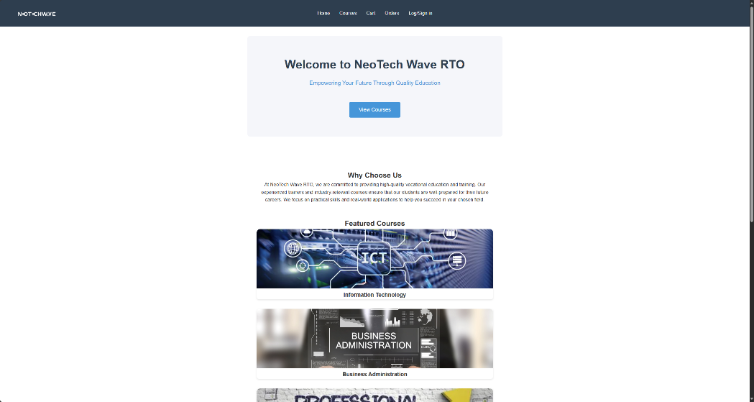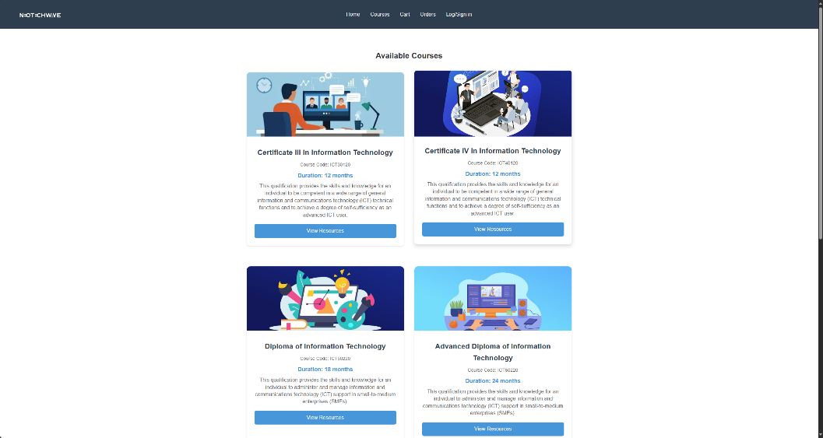  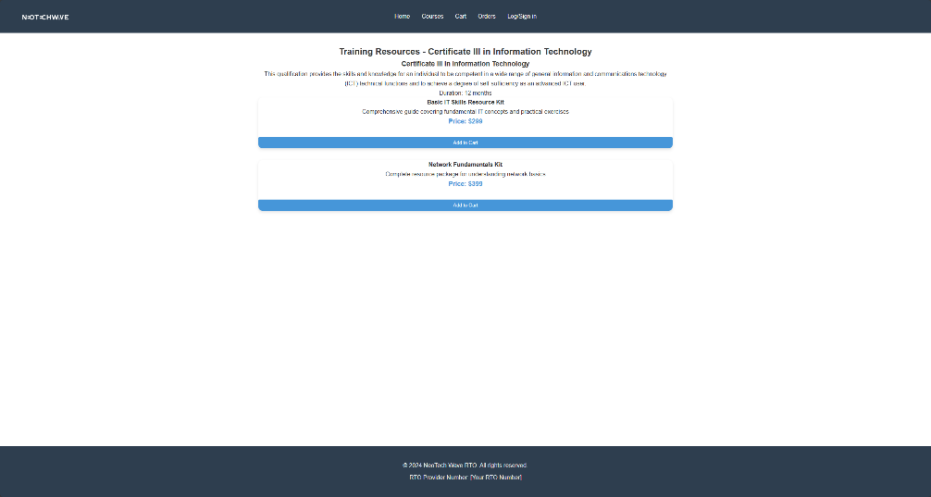  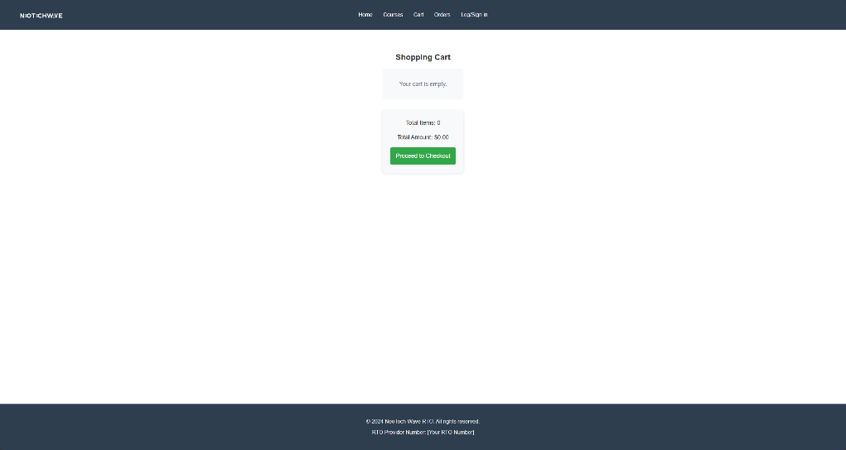  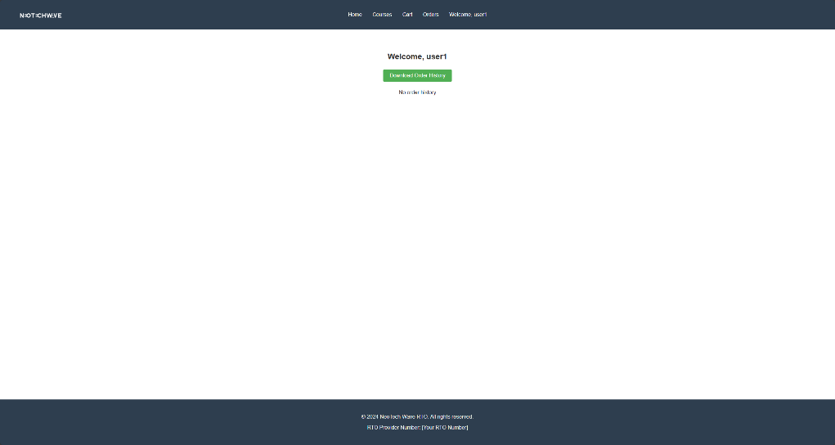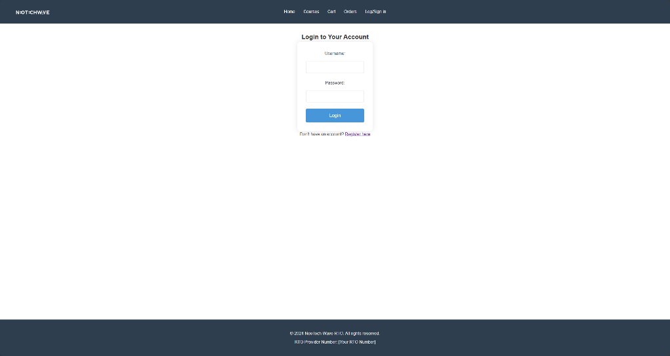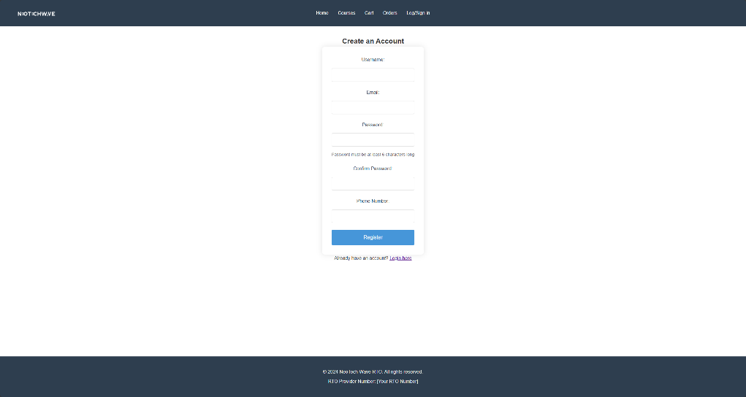  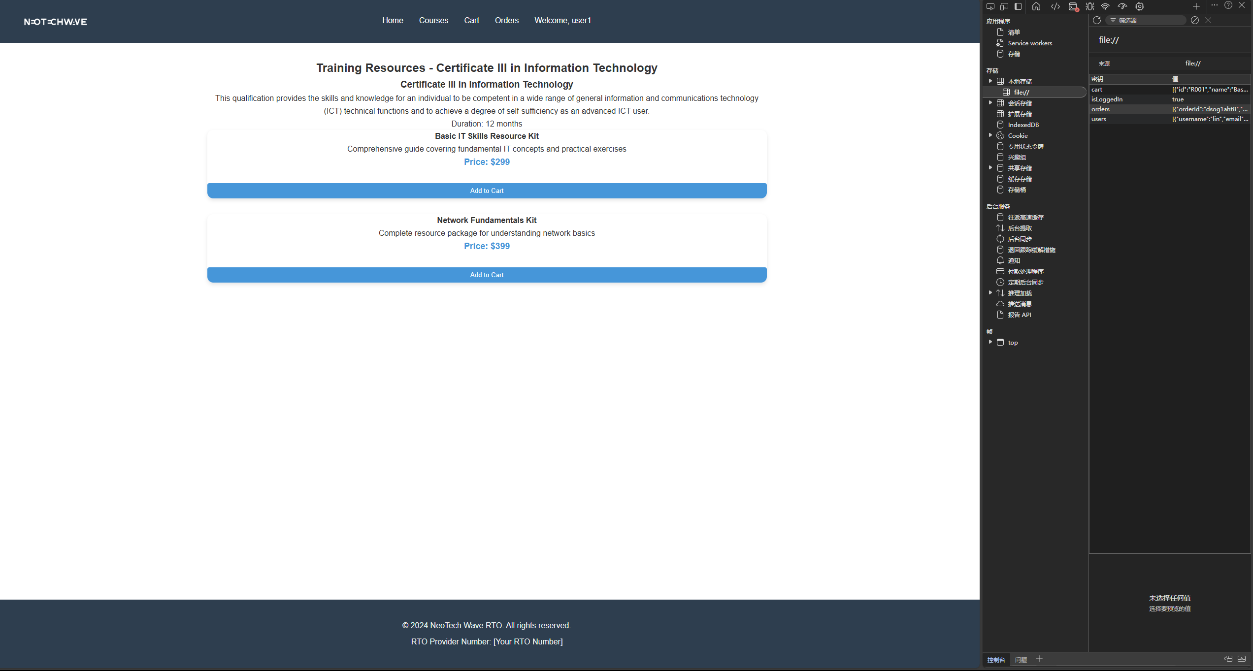 | ☐

Last updated: 18 May 2025

